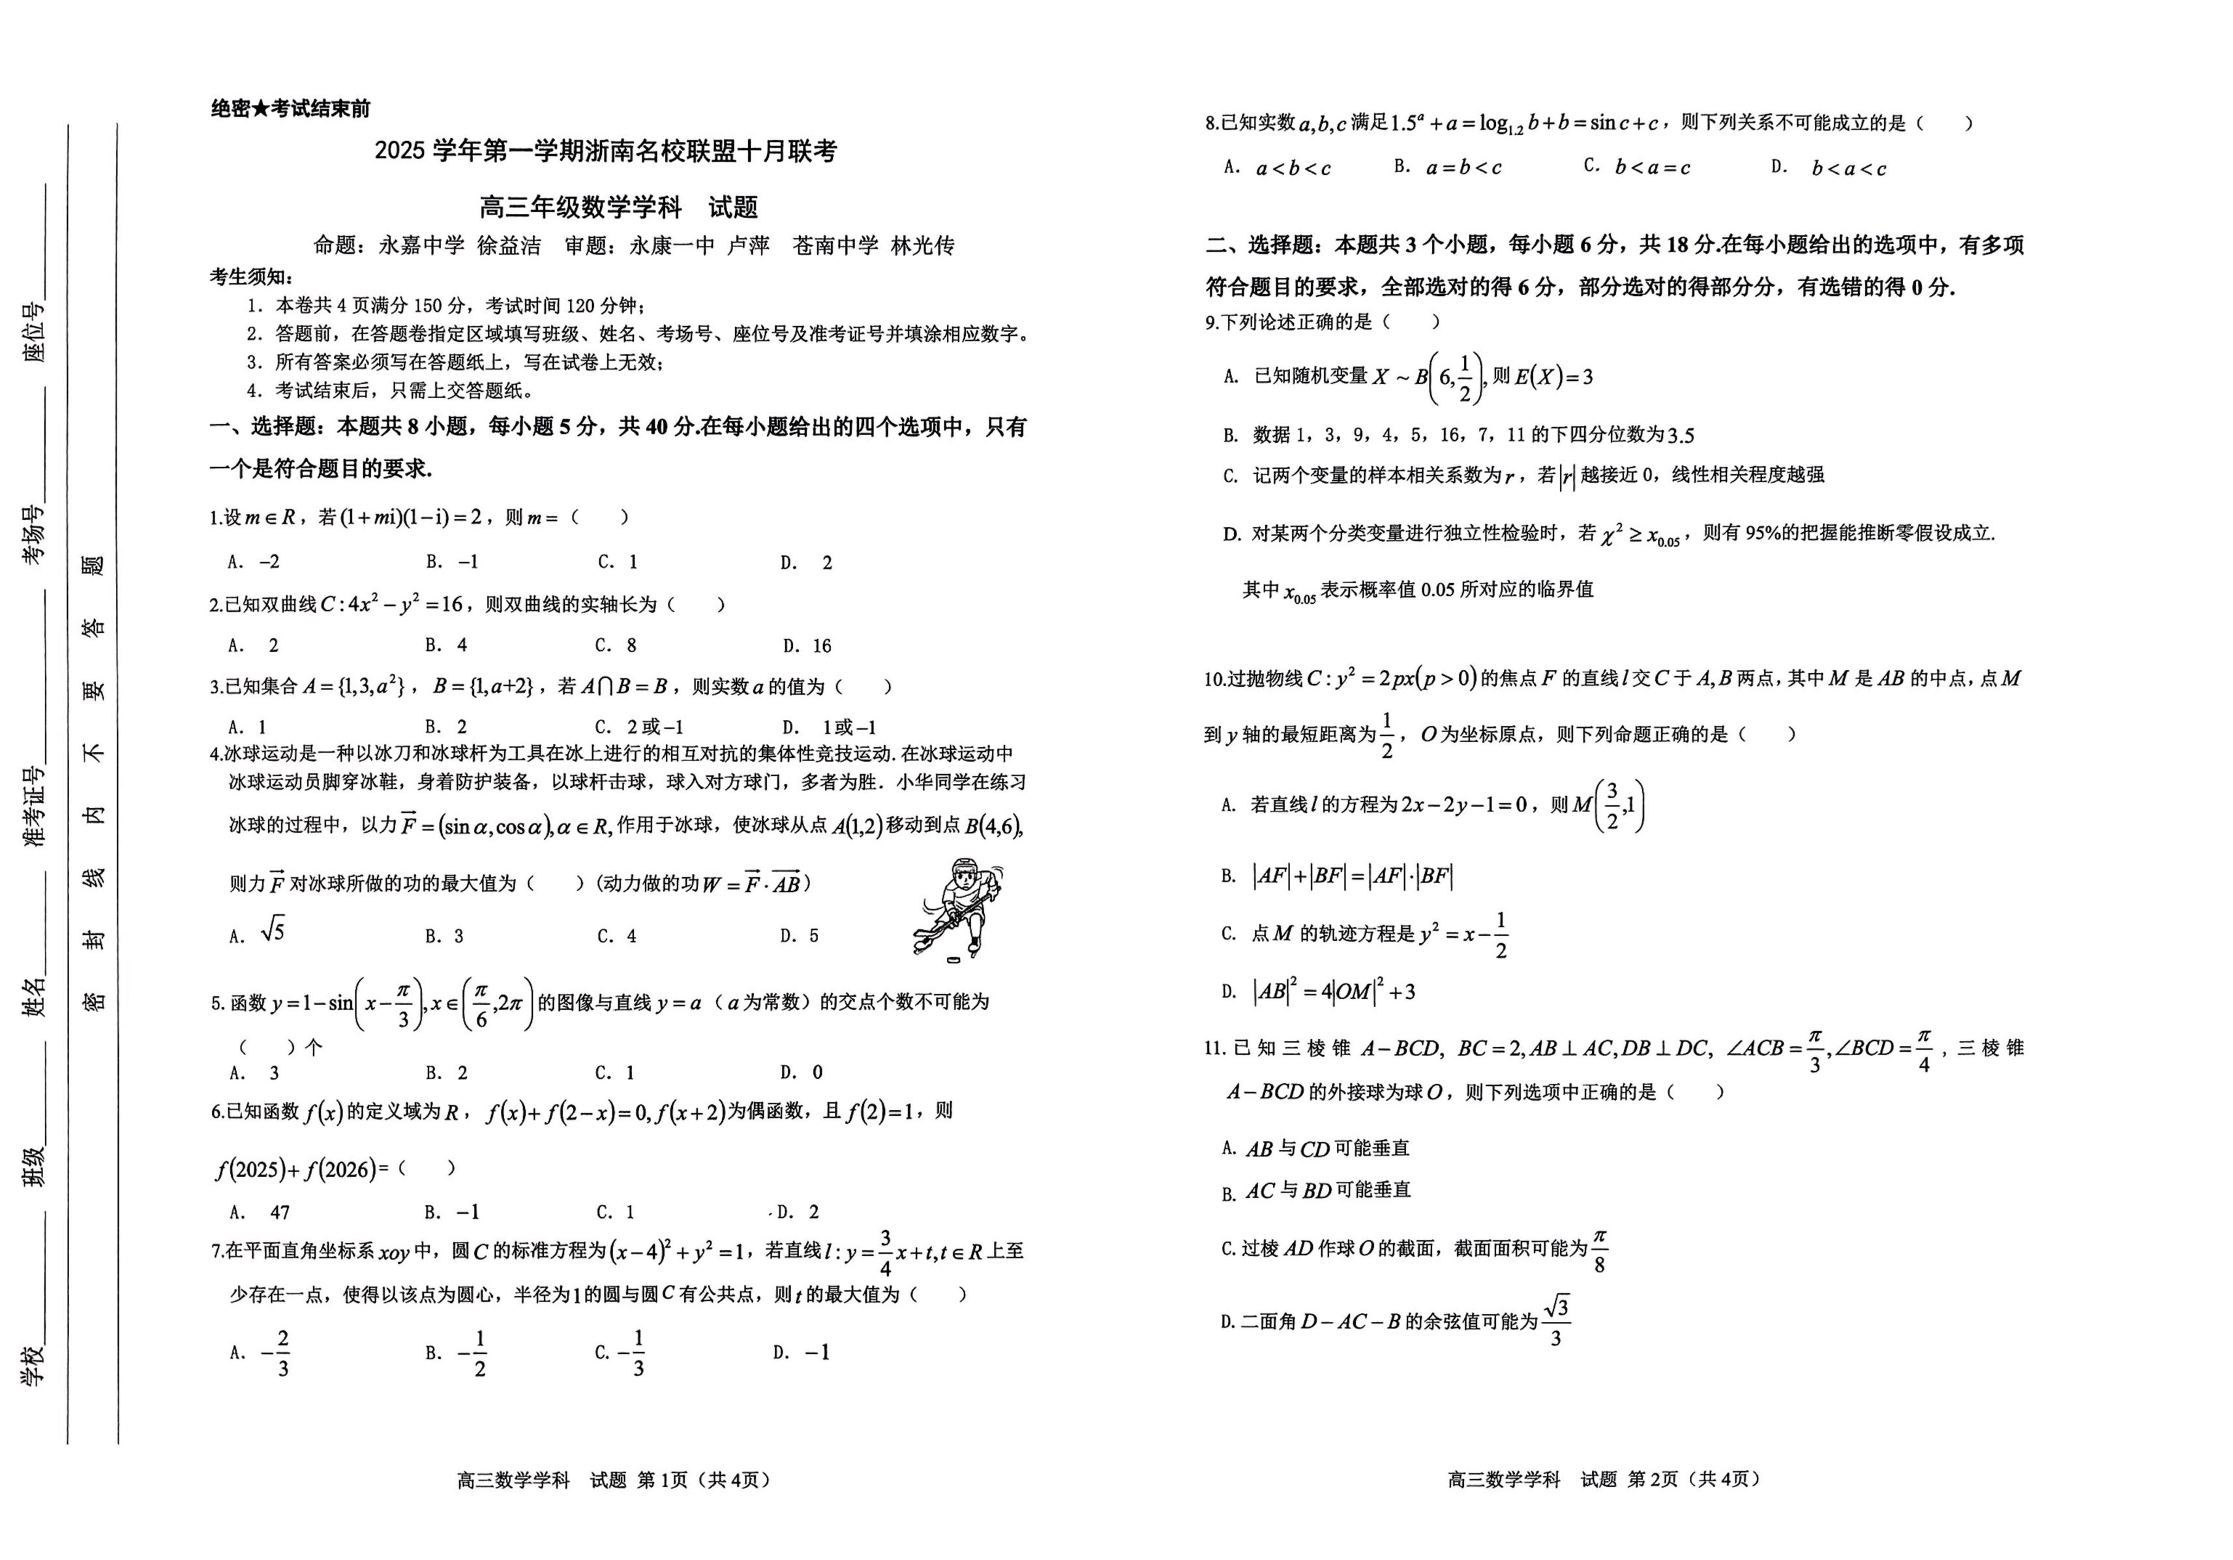{#{QQABLYC44gAYkJbACJ4LEUU0CgoQkICiLeokhVCWqA4iCBFABAA=}#}

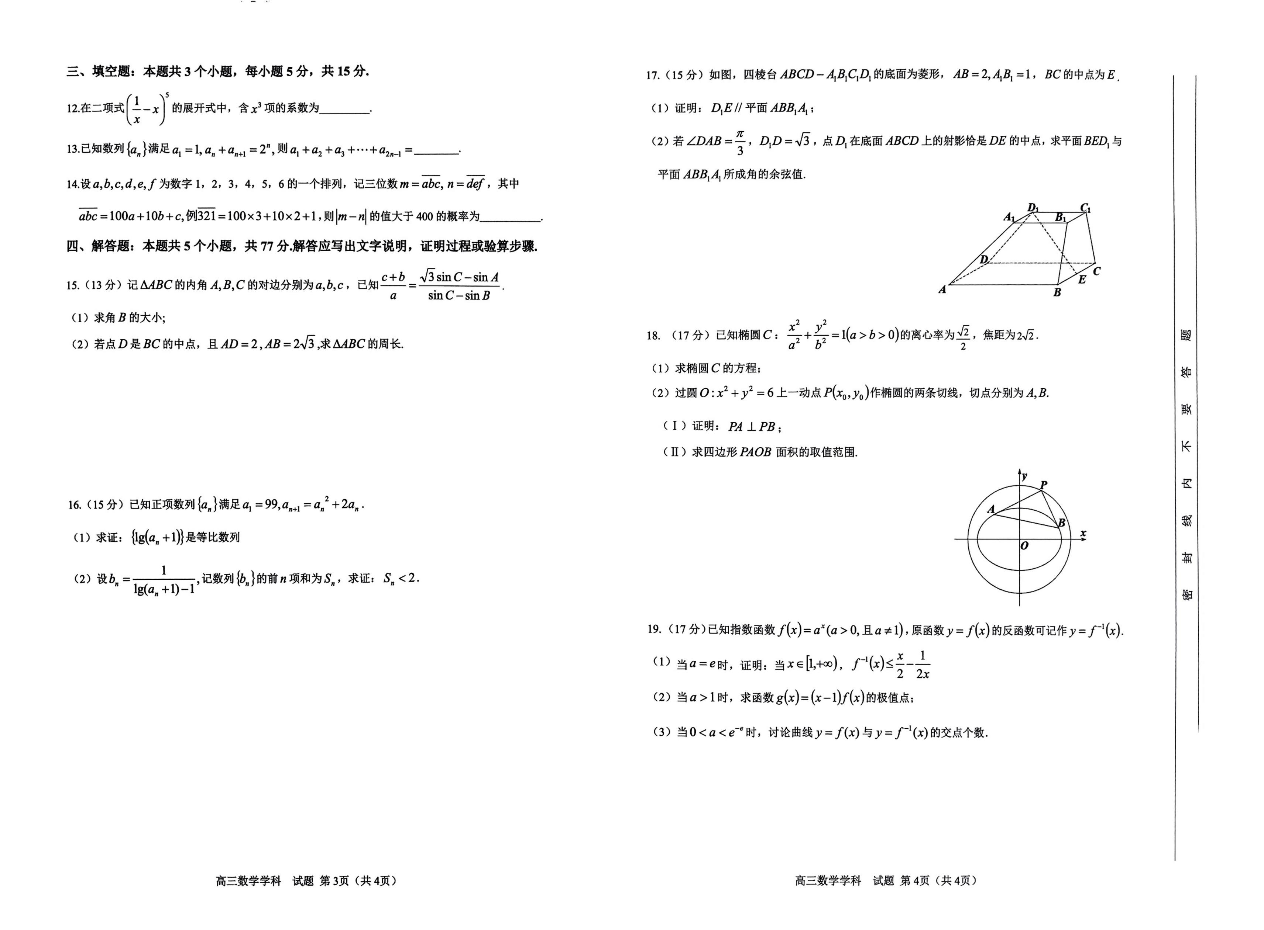{#{QQABLYC44gAYkJbACJ4LEUU0CgoQkICiLeokhVCWqA4iCBFABAA=}#}

