高中英语图表作文（通常是看图写作或图表描述）是考试中的重要题型，它主要考查学生的观察能力、信息归纳能力和语言表达能力。
掌握以下技能，你就能写出一篇高分图表作文。
- 作文结构 (Structure) 三段式最稳妥，一篇结构清晰的作文是高分的基础。
· 第一段：引言 (Introduction) 约1-2句
· 目的：开门见山，概括介绍图表内容。
· 要素：说明图表类型（饼状图、柱状图、曲线图、表格pie charts, bar charts,curve graphs, tables等）、主题（关于什么的数据）和时间范围。
· 常用句型：
· The chart / graph / table / pie chart shows / illustrates / presents the data about...
· As can be seen from the chart...从图表中可以看出
· According to the survey results...根据调查结果
·As shown in the figure/ as shown in Fig. 如图所示。
·As illustrated in the diagram如图所示。
·As seen in the chart 如图所示。
例句：The data distribution, as shown in the figure, indicates a clear upward trend.数据分布如图所示，呈现明显的上升趋势。
例句：The working principle of the machine, as illustrated in the diagram, can be easily understood.如图所示，该机器的工作原理易于理解。
· 第二段：主体 (Body) - 约4-6句· 目的：详细描述图表中的主要趋势、最大值、最小值、对比和显著特征。不要简单地罗列所有数据！
· 策略：
1. 总体描述：先概括总体趋势（是上升、下降还是波动？）。
2. 突出极值：指出最高点 (the highest) 和最低点 (the lowest)。
3. 对比分析：比较不同数据之间的相同点和不同点。
4. 选择关键数据：引用最具代表性的一两个数据来支撑你的描述。
· 第三段：总结 (Conclusion) - 约1-2句
· 目的：对图表信息进行总结，并可以简要推断原因或预测趋势。
· 注意：结论必须基于图表内容，不能凭空想象。
· 常用句型：
· In conclusion / To sum up / Overall...总之 /总而言之 /概括地说
· It can be concluded that...可以得出结论 /可以断定
二、 核心词汇与句型 (Vocabulary & Sentence Patterns)
1. 描述趋势 (Describing Trends)
· 上升：increase / rise / grow / go up / climb
· There was a sharp increase in the number of...
· The figure rose steadily from 2020 to 2023.
· 下降：decrease / fall / drop / decline / go down
· We can see a slight decrease in the percentage of...
· The rate dropped dramatically to 10% in 2022.
· 保持平稳：remain stable / steady / stay the same； level off趋向平稳
· The number remained stable over the period.
· 波动：fluctuate
· The price fluctuated between $5 and $10.
2. 描述程度 (Describing Degree)
· 急剧地：sharply / dramatically / rapidly / significantly
· 缓慢地：slowly / gradually / slightly / modestly
· 大约：about / approximately / around
3. 表示占比 (Describing Proportions)
· account for... (占据...)； make up... (组成...)； occupy... (占有...)
a quarter of / Half of / Three quarters of... (四分之一/一半/四分之三)
e.g: 1，Students account for 60% of the users.
4. 表示对比 (Making Comparisons)
· Similarly, ... (同样地，...) ； ... while / whereas ... (...，而...)
In contrast, ... / On the contrary, ... (相比之下，...)
e.g: 40% of people prefer coffee, whereas 60% prefer tea.
三、 高分技巧 (High-Score Tips)
1. 同义替换：避免重复使用同一个词。例如，show 可以换成 illustrate（举例说明 /说明 /阐明 /图解）, demonstrate（证明 /演示 /论证 /彰显）, present；increase 可以换成 rise, growth。
2. 多样性句式：不要全是The number increased...这样的简单句。尝试使用：
· 定语从句：The data which was collected in 2023 shows that...
· 状语从句：As time went by, the figure increased.
· 分词结构：Seen from the chart, the trend is clear.
3. 时态准确：根据图表给出的时间决定时态。
· 如果是过去时间，用一般过去时。
· 如果是经常性情况或无时间，用一般现在时。
· 如果预测未来趋势，用一般将来时。
4. 不主观臆断：只描述你看到的信息，不要添加图表中没有的内容。结论部分的推断也要合理有据。
实战范例 (Example) 假设题目是一个关于学生业余活动分配的饼状图 (Pie Chart)。
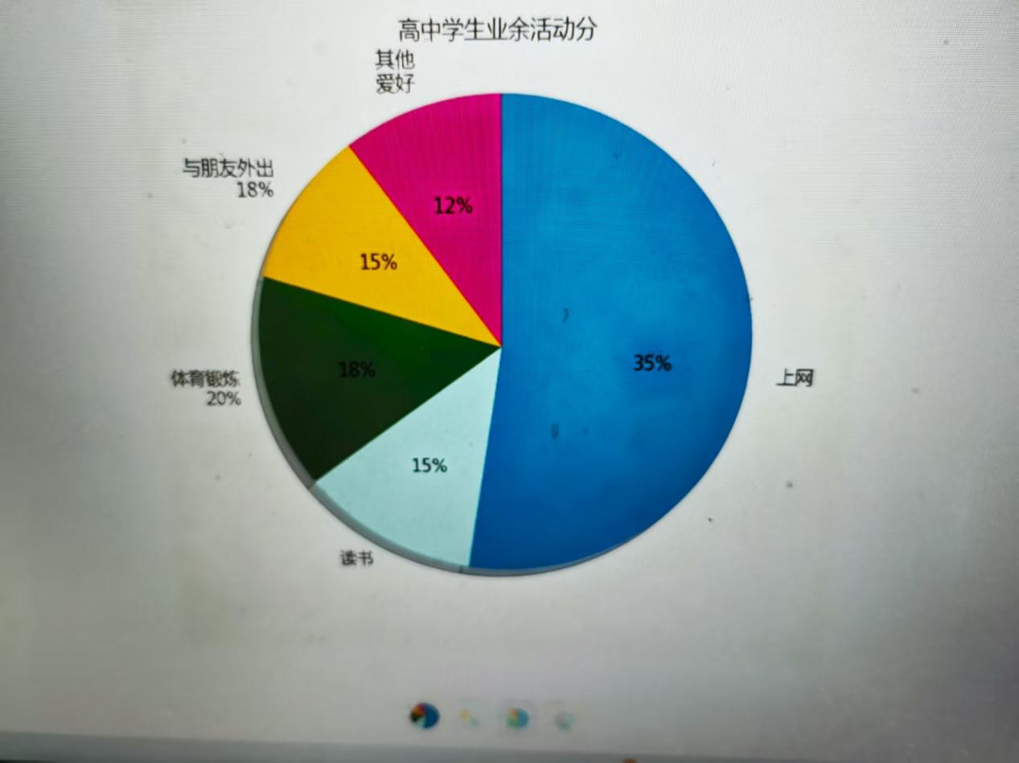
The pie chart illustrates how high school students allocate their free time among five different activities.（Introduction:）
As can be seen, surfing the Internet accounts for the largest proportion at 35%, making it the most popular activity. In contrast, reading books only makes up 15%, which is the smallest share. It is worth noting that doing physical exercises and hanging out with friends occupy similar portions, at 20% and 18% respectively. The remaining 12% of time is spent on other hobbies（Body）
Overall, the chart clearly shows that a significant majority of students prefer to spend their leisure time online rather than on traditional activities like reading or sports.（Conclusion）
南京外国语试卷范文
Learning English Beyond the Classroom
There are many things we can do to learn English well. Recently a survey about how to learn English beyond the classroom has been conducted. As can be clearly seen from the statistics, appreciating English songs accounts for 65 percent compared with 50% who choose to watch movies as a way of English learning. Reading English books prove to be the less popular ways making up 18%, together with visiting English learning websites, taking up 12% .
It turns out that students attach greater importance to interest and entertainment instead of traditional approaches such as reading books when learning English.
However, from my point of view, what benefits students most is reading English books, for it is one of the best ways to enlarge vocabulary and to strengthen the understanding of grammar. Therefore, students become best English learners quickly.
要学好英语，我们能做的事有很多。最近，一项做了一项关于“如何在课堂之外学习英语”的调查。从统计数据中能清晰看出，通过欣赏英文歌曲学习英语的比例占65%，相比之下，选择看电影作为英语学习方式的比例为50%。阅读英文书籍是较不受欢迎的方式之一，占比18%；访问英语学习网站的占比则为12%。
事实证明，学生在学习英语时，更看重兴趣和娱乐性，而非读书这类传统学习方式。
不过，在我看来，最能让学生受益的是阅读英文书籍，因为这是扩充词汇量、加深语法理解的最佳方式之一。因此，学生能更快地成为优秀的英语学习者。
读后续写范文
Every morning for the next two weeks, Lenna woke Elsa up at 4:30 to run. At first Elsa didn’t want to move and Lenna was able to review her vocabulary while jogging alongside her, but by the end of the two weeks, Lenna actually had to sweat a bit to keep up with her. Every day after school, Elsa would drag Lenna into the school library. The girls would talk as Lenna periodically caught on to（ 理解，流行）a difficult concept during these marathon study sessions.
Final report cards were distributed the Monday before graduation. Lenna and Elsa agreed to meet up at the library after school to open their report cards together. To their surprise, when Lenna unfolded her report card, she got a “B” in science class and would meet the terms of her scholarship. Elsa got an “A” in gym class. With another perfect report card in hand, she would surely edge out Chet Good weather to become the top student.

