浙江省2013年高考模拟冲刺（提优）测试二英语试题第I卷 (共80分)
第一部分：英语知识运用（共两节，满分30分）
第一节：单项填空（共20小题；每小题0.5分，满分10分）
1. ---Oh, no，where is my key?
--- ______________! You will find it sooner or later．
A．Take your time B．Don’t take risks C. Come on D. Take it easy
2. Some of the books appear to be _______ ones that you have read, but after taking _______ second look, you will find that they are different.
A. /; a B. the; the C. the; / D. the; a
3. Lucy has already tried her best. Please don’t be too ______ about her job.
A. curious B. special C. particular D. responsible
4. I value my friend Tom’s friendship very much, but _______ I dislike his selfishness.
A. in addition B. as well C. on the other hand D. in other words
5. A new laptop costs about _____ of a second-hand one.
A. the price of three times B. three times the price
C. as much as the three times price D. three times more than the price
6. It was nearly an hour _____________ the sleeping pill _____________ effect.
A. when; took B. before; took C. since; takes D. before; would take
7. --- Do you want anything else for your birthday?
--- Nothing else. I’m very ______ with what you’ve bought for me.
A. satisfying B. honest C. content D. disappointed
8. — Mary’s sister looks very beautiful now.
— But she was very ugly before she tidied up her appearance（整容）. You _________ believe it!
A. shouldn’t B. mustn’t C. wouldn’t D. might not
9. I can hardly imagine the difficulty she had ______ enough evidence to prove that she was innocent.
A. collected B. to collect C. to have collected D. collecting
10. — Are you going to travel during this summer vacation?
— No, I’ll have to do some part-time job for my study. __________, there’s a disease spreading.
A. Also B. Therefore C. However D. Unluckily
11. --- Mike spends a lot of his spare time on computer games.
--- So does my son. The children have become hopelessly ________the games.
A. devoted to B. addicted to C. bored with D. disappointed with
12. Tom, ________________ you from taking a hand in that affair, you ______________ in prison.
A. if I didn’t stop; would have stayed B. had I stopped; would be staying
C. shouldn’t I have stopped; would stay D. if I hadn’t stopped; would have stayed
13. .---Doris, do you have anything in mind______________ you’d like for breakfast ?
---_______________ is okay with me. I’m not particular about food.
A. that; Anything B. which; Everything C. what; Nothing D. whether; Something
14. When they built this office block, they gave no _________ to the disabled.
A. wonder B. worry C. advice D. thought
15. The company used 50 percent of the raw materials, the rest of which __________ sent to other cities to help the factories there.
A. is B. was C. are D. were
16. Many strange new means of transport have been developed in our century, the strangest of _______ being perhaps the hovercraft(气垫船).
A. which B. them C. that D. it
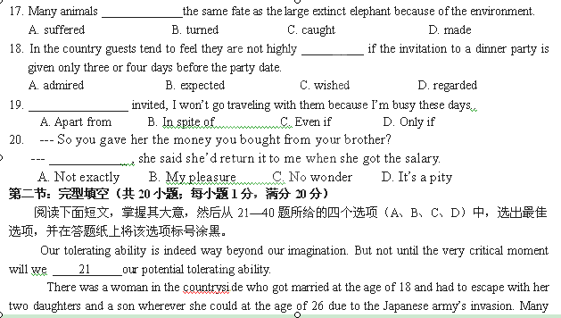people in the village at that time could not 22 the suffering of being a fugitive（亡命者） and wanted to commit suicide. After she knew about it, she would come to those 23 ,saying, “Don’t do that 24 thing. There are no such setbacks(挫折) that we could not overcome!”
Finally she insisted until the day when all the Japanese armies were kicked out of China. 25 , her son died of disease without sufficient 26 and nutrition in those days of hardships. Her husband, after knowing the death of his son, lay in bed for two days without eating and drinking anything. She teared to her husband and said, “We have a tough destiny, but however tough our lives will be, we should also 27 . Though our son has passed away, we can have another. ”
After giving birth to the second 28 , her husband died of edema（水肿病）, which almost 29 her away. But eventually, she 30 and held the three young children in her arms, saying, “My sweet hearts, don’t feel scared. You still have me, your dear mum!”
It took her pain efforts to 31 her children up and the life of her family was getting better and better. Two daughters were married and so was his son finally. She said to everyone she met, “Look! What I said is 32 right. There are no such setbacks that we could not overcome! My life is so happy now!” She was 33 gradually and could not do the farm work anymore. So she stayed at home and did some sewing work.
Nevertheless, the Heaven seemed to show no affection to her who had undergone a 34 life. She got her leg broken 35 when she was nursing her grandson. Due to her old age that posed a great risk to her operation, she did not receive operation and had to lie in bed all day long. Her children all cried heavily, while she merely said, “Why do you cry? I am still living.”
36 she could not rise from bed, she did not complain about anything and anybody. Instead, she sat on the bed and did some sewing work. She had learnt scarves-weaving, crafts-making, etc. All her neighbors spoke 37 of her skills and came to learn from her.
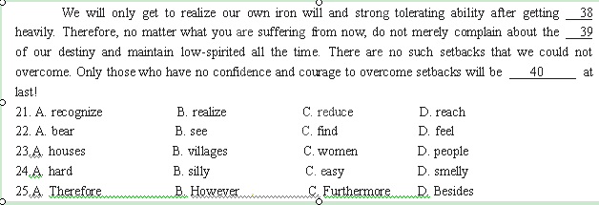She lived until 86. Before she went to Heaven, she said to her children, “You all should live to your best. There are no such setbacks that we could not overcome!”
26.A. food B. water C. medicine D. clothes
27.A. persist B. help C. work D. accept
28.A. child B. son C. daughter D. baby
29.A. get B. give C. blew D. put
30.A. stopped B. cried C. sighed D. recovered
31.A. raise B. teach C. build D. love
32.A.nearly B. absolutely C. almost D. naturally
33.A.dying B. growing C. aging D. complaining
34.A. happy B. long C. normal D. rough
35.A. purposely B. accidently C. suddenly D. quietly
36.A.As though B. Even though C. As long as D. Ever since
37.A. happily B. loudly C highly D. formally
38.A. hurt B. ill C. excited D. stricken
39.A. unfairness B. unhappiness C. unfitness D. uncomfortableness
40.A. hit B. improved C. defeated D. hurt
第二部分：阅读理解（第一节20小题，第二节5小题；每小题2分，满分50分）
第一节：阅读下列短文，从每题所给的四个选项（A、B、C、D）中，选出最佳选项，并在答题纸上将该选项标号涂黑。
A
They can be seen more frequently than ever before on college campuses, wearing thick-rimmed glasses while listening to indie(独立的) music. One might find them playing unusual musical instruments, shopping at second-hand stores or expressing themselves in other unique ways. They call themselves hipsters. Being “hip” used to mean following the latest fashion. But gradually the word has evolved into a synonym for “cool”.
Hipsters value independent thinking, progressive politics, an appreciation of creativity and intelligence. Hipsters take pains and pride in not being mainstream. However, their culture has become quite trendy. This irony is central to their culture and offers an interesting paradox.
“I do take things in the mainstream with a grain of salt,” says Ben Polson, a college student at Brown University in the US. Polson describes himself as a hipster and says he often questions what determines popularity, especially regarding music.When lesser-known bands become popular they often lose their former fan base in exchange for a new one. There is a famous hipster saying that goes: I used to like that band before it got popular.
According to Polson, bands’ music changes when they go mainstream. They become “less experimental, doing things just to save popularity and fans. The original elements that we were drawn to slowly dwindle for the sake of popularity.”
Many young adults have started to view hipsters’ outlook as cool and are adopting their counterculture mindset (心态)themselves. This has led to specialized brands, stores and music for the hipster position. Ironically, some such stores, including clothing labels Urban Outfitters and American Apparel, have gained mainstream popularity. This has seemingly diluted(冲淡) the anti-mainstream culture.
“A lot of people that are self-defined hipsters aren’t really hipsters, they’re just trying to conform to the non-conformist(不墨守成规者) to seem cooler,” says Amanda Leopold, a college student from Oberlin College, US. Although Leopold has many unconventional tastes and seems quite individualist, she refuses to classify herself as a hipster.
There is a conflict among hipsters about the very definition of the label. To some, to be a hipster is to be free from cultural constraints. To others, it means wearing a certain style and listening to a specific style of music. The former constantly strives for uniqueness, while the latter strives not to be mainstream.
And yet, the movement is gaining mainstream popularity. “It’s kind of the trend these days; everyone wants to be hip so no one’s hip,” says Leopold. “There have been hipsters since the seventies. It’s only become popular recently.”
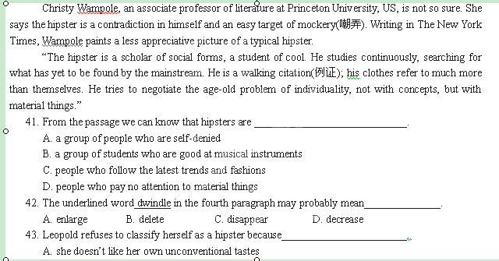Hipsters reject materialism and laugh at mainstream culture. But are they really beyond material comforts? Do they have any ideas of their own if they despise mainstream so much?
B. there are too many specialized brands, stores and music for the hipster position
C. she thinks that a lot of people that are self-defined hipsters aren’t really hipsters
D. the hipsters’ culture has become quite trendy
44. When Leopold said “It’s kind of the trend these days; everyone wants to be hip so no one’s hip”, we
can see that she felt a bit ______________.
A. happy B. disappointed C. excited D. content
45. The passage mainly tells us ________________________.
A. the difficult situation of hipsters B. the trend of fashion
C. the changes of the society D. the culture of hipsters

B
Nowadays, a cellphone service is available to everyone, everywhere. Probably thousands of people have already been using it, but I just discovered it, so I'm going to claim it and also name it: Fake Foning.
The technology has been working well for me at the office, but there are infinite(无限的） applications. Virtually in any public space.
Say you work at a big university with lots of talky faculty members buzzing about. Now, say you need to use the restroom. The trip down the hall will take approximately one hour, because a person can't walk into those talky people without getting pulled aside for a question, a bit of gossip, a new read on a certain line of Paradise Lost.
So, a cellphone. Any cellphone. Just pick it up. Don't dial. Just hold that phone to your face and start talking. Walk confidently down the hall engaged in fake conversation, making sure to tailor both the topic and content to the person standing before you whom you are trying to avoid.
For standard colleague avoidance, I suggest fake chatting about fake business:
"Yes, I'm glad you called, because we really need to hammer out the details. What's that? Yes, I read Page 12, but if you look at the bottom of 4, I think you can see the problem begins right there."
Be engaged in your fake fone conversation. Make eye contact with the people passing, nod to them, gesture keen interest in talking to them at a later time, point to your phone, shrug and move on.
Shoppers should consider fake foning anytime they spot a talky neighbor in the produce department pinching (用手捏) unripe peaches. Without your phone at your face, you'd be in for a 20-minute speech on how terrible the world is.
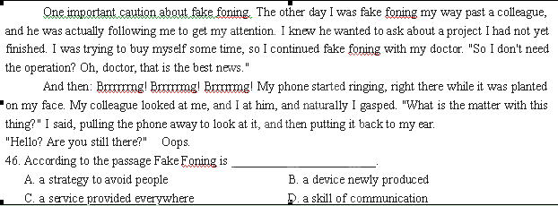47. In the author's opinion, in order to make fake foning look real one has to__________________.
A. talk about interesting matters B. behave politely to people passing by
C. hold the phone while walking D. appear absorbed in conversation
48. What does the last example show?
A. One effective way is to fake fone one's doctor. B. One has to be careful while fake foning.
C. Fake foning may not cheat people. D. Fake foning is always quite successful.
49. After his phone suddenly began ringing, the author___________________.
A. immediately started talking to the caller B. immediately started talking to his colleague
C. put the phone away and stopped talking D. continued with his fake conversation
50. What is the tone of the passage?
A. Critical. B. Humorous. C. Serious. D. Unclear.

C
Boots(men's)  By the Union Team. Leather with plastic sole(鞋底)  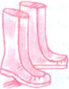  Sizes:3,4,5  Order number:  PQ 2544 red  PQ 2545 dark brown  Price:￡29.99 | The magic jeans collection(women's)  Stretch jeans in blue, black, red.  Made to sit slightly lower than natural waistline at front. Zip fastening. Washable.  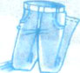  Made of:96% cotton,4% elastane(弹性纤维).  Sizes:10,12,14,16  Order number:  GQ 8487 blue  GQ 8488 black  Price: ￡24.99
Three-quarter length  jacket(women's)  Fashionable leather. Length 34 inches.  Do not hand clean.  Sizes:10,12,14,16,18  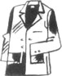  Order number:  CQ 8200 black  CQ 8201 black  Price: ￡99.99  Insure your leather jacket against being stolen and accidental damage. For details see Page 1143. | Epaulette shirt(men's)  Short-sleeved shirt with sleeve and shoulder epaulettes(肩章),button-down collar and two button-down chest pockets. Washable. Cotton.  Sizes:S(35/37),M(38/40),L(41/43),XL(44/46)  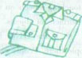  Order number:  KQ 8149 blue  KQ 8151 green  Price: ￡14.99
Classic rugby shirts(men's)
In the same style as your rugby team-Scotland, England or Wales. All our stylish rugby shirts are genuine leisure shirts too. They're all machine washable and in 100% cotton.
Sizes: S,M,L,XL
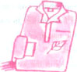
Order number:
Scotland shirts:DQ9967
England shirts: KQ 9963
Wales shirts: KQ 9978
Price: ￡19.99

51.The soles of the boots for men are made of ____________________.
A. leather B. elastane C. cotton D. plastic
52.The stretch jeans come in __________ colours and ______________ sizes.
A.2; 3 B.3;3 C. 3;4 D. 4;4
53.From the above chart we can see clearly that _______________________________________.
A. the shirts listed in the chart are genuine leisure shirts
B. all the clothes listed in the chart can be washed both by hand and machine
C. you can insure your three-quarter length jacket against being stolen and accidental damage
D. the magic jeans may be in 100% cotton
54. It will cost you ______________ to buy two epaulette shirts.
A. 99.99 pounds B. 29.98 pounds C. 49.98 pounds D. 38.98 pounds
55.The order number for the England rugby shirts is________________.
A. KQ9963 B. DQ9967 C. KQ 9978 D. KQ 8149

D
It was late in the afternoon, and I was putting the final touch on a piece of writing that I was feeling pretty good about. I wanted to save it, but my cursor(光标) had frozen. I tried to shut the computer down, and it seized up altogether. Unsure of what else to do, I yanked (用力猛拉) the battery out.
Unfortunately, Windows had been in the midst of a crucial（紧要关头） undertaking. The next morning, when I turned my computer back on, it informed me that a file had been corrupted and Windows would not load. Then, it offered to repair itself by using the Windows Setup CD.
I opened the special drawer where I keep CDs. But no Windows CD in there. I was forced to call the computer company's Global Support Centre. My call was answered by a woman in some unnamed, far-off land. I find it annoying to make small talk with someone when I don't know what continent they're standing on. Suppose I were to comment on the beautiful weather we've been having when there was a monsoon(季风) at the other end of the phone? So I got right to the point.
"My computer is telling me a file is corrupted and it wants to fix itself, but I don't have the Windows Setup CD."
"So you're having a problem with your Windows Setup CD." She has apparently been dozing and, having come to just as the sentence ended, was attempting to cover for her inattention.
It quickly became clear that the woman was not a computer technician. Her job was to serve as a gatekeeper. Her only duty, as far as I could tell, was to raise global stress levels.
To make me disappear, the woman gave me the phone number for Windows' creator, Microsoft. This is like giving someone the phone number for, I don't know, North America. Besides, the CD worked; I just didn't have it. No matter how many times I repeated my story, we came back to the same place. She was calm and polite.
When my voice hit a certain decibel (分贝), I was passed along, like a hot, irritable potato, to a technician.
"You don't have the Windows Setup CD, ma'am, because you don't need it," he explained cheerfully.
"Windows came preinstalled on your computer!"
"But I do need it."
"Yes, but you don't have it." We went on like this for a while. Finally, he offered to walk me through the use of a different CD, one that would erase my entire system. "Of course, you'd lose all your e-mail, your documents, your photos." It was like offering to drop a safe on my head to cure my headache. "You might be able to recover them, but it would be expensive." He sounded delighted. "And it's not covered by the warranty (产品保证书)!" The safe began to seem like a good idea, provided it was full.
I hung up the phone and drove my computer to a small, friendly repair place I'd heard about. A smart, helpful man dug out a Windows CD and told me it wouldn't be a problem. An hour later, he called to let me know it was ready. I thanked him, and we chatted about the weather, which was the same outside my window as it was outside his.
56. Why did the author shut down her computer abruptly?
A. She had saved what she had written. B. She couldn't move the cursor.
C. The computer refused to work. D. The computer offered to repair itself.
57. Which of the following is the author's opinion about the woman at the Global Support Centre?
A. She sounded helpful and knowledgeable. B. She was there to make callers frustrated.
C. She was able to solve her computer problem. D. She was quick to pass her along to a technician.
58. According to the passage, the solution offered by the technician was_________________.
A. effective B. economical C. unpractical D. unsatisfied
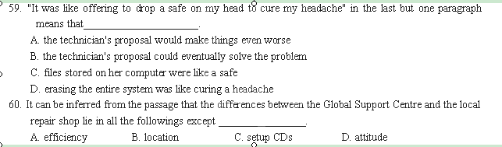
第二节：下面是生活中的几条小建议，有5处（第61~65题）需要添加小标题。请从以下选项（A、B、C、D、E和F）中选出符合各条建议的小标题，并在答题纸上将相应选项的标号涂黑。选项中有一项是多余选项。

61._______________
You can try your hardest, you can do everything and say everything, but sometimes people just aren’t worth trying over anymore, and they aren’t worth worrying about. It’s important to know when to let go of someone who only brings you down. The moment someone tells you that you’re not good enough is the moment you know you’re better off than they are, and better off without them.
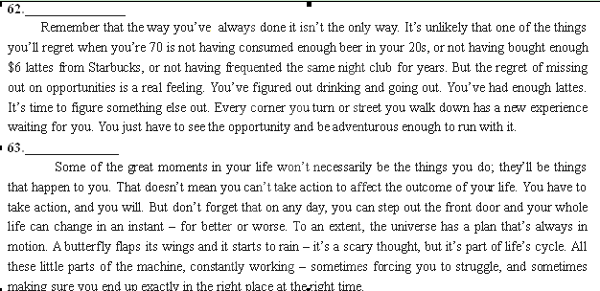
64.______________
Life is too short to wait. Every new day is another chance to change your life. Every great accomplishment starts with the decision to try. Trust that little voice inside your head that says, “What if…” and then GO DO IT. You would be surprised how often “what if” works. And no, you’re not obligated to win every time. You’re obligated to keep trying – to do the best you can do every day – to be better than you were yesterday.
65.______________
Your ideas and choices don’t have to be on everyone’s list. Regardless of the opinions of others, at the end of the day the only reflection staring back at you in the mirror is your own. Make sure you’re proud of who that person is. Approach others with the belief that you’re a good person, whether they respond positively or not. It’s normal to want the people around you to like you, but it becomes a self-imposed burden when too much of your behavior is designed to constantly comfort others.

A. Always keep in mind that life is somewhat unpredictable.
B. Trust your instincts on new opportunities.
C. Introduce a little variety into your routine.
D. Accept some responsibility for the way others treat you.
E. Seek less approval from others.
F. Let the wrong people go.

第Ⅱ卷（共40分）
第三部分：写作（共两节，满分40分）
第一节：短文改错（共10小题；每小题1分，满分10分）
下面短文中有10处语言错误。请在有错误的地方增加、删除或修改某个单词。
增加：在缺词处加一个漏字符号（∧），并在其下面写上该加的词。
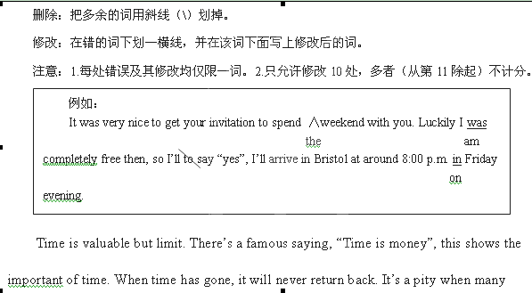
people make poorly use of time. They spend their precious time oversleeping, drinking and

traveling. They don’t realize wasting time is equal to waste part of their life. They always

regret having made little achievement so far. Therefore, we should form the habit valuing

time. Don’t put off that can be done today until tomorrow. Laziness will not only bring us

failure, but also lead us on the road of poverty and even death.

第二节 书面表达 (满分30分)
一个来自美国的参观团要到你的家乡来参观考察。假设你是他们的导游，请口头向外国朋友们介绍你的家乡。要点如下：
1. 自然资源丰富，盛产苹果。人口有500多万，其中50%是教师、工人、机关工作人员等；
2 自2000年以来工业发展迅猛，拥有一个近十万人口的开发区；
3. 人们重视教育，40%的人受过高等教育。建有50多所中学，200多所小学;
4. 交通便利，有一个火车站、一个国际机场和一个港口，连接国内外主要城市;
5. 可适当增加内容。
注意：1、要求语言流畅，内容连贯；2、字数100—120 ；3、开头已为你写好（不计入词数）。

Welcome to our hometown for an inspection. …

___________________________________________________________________________________

___________________________________________________________________________________

___________________________________________________________________________________

___________________________________________________________________________________

___________________________________________________________________________________

___________________________________________________________________________________

2013年浙江省高考模拟冲刺卷（提优卷）
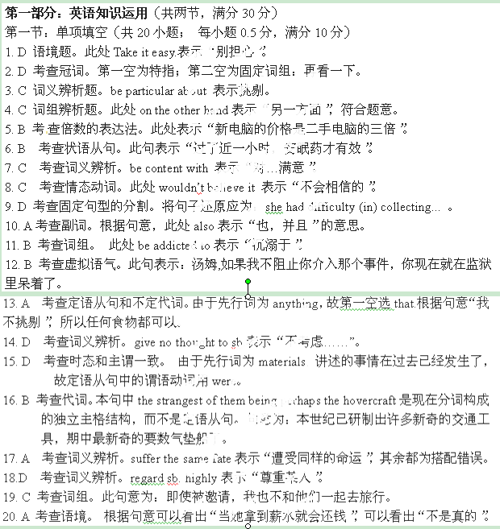英语（二）参考答案
第二节：完型填空（共20小题；每小题1分，满分20分）
21. B 此处表示“不到关键时刻，我们很少能认识到自己忍受的潜力有多大”。
22. A 此处表示“忍受折磨”。
23. D 此处表示她去劝那些想自杀的人们。
24. B 这里表示不要去干自杀那种蠢事。
25.B 这里表示转折关系。
26.C 由于上文提到她儿子died of disease可知那时没有足够的“药物和营养”。
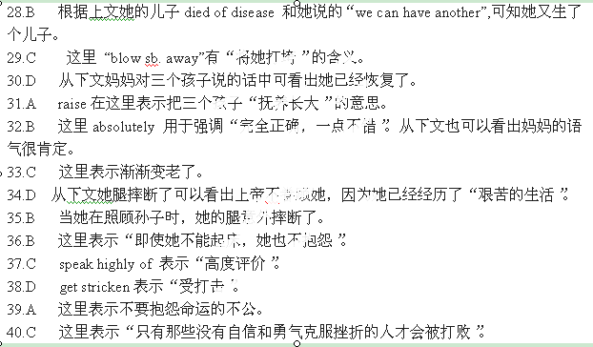
27.A 这里表示“无论生活多么艰苦，我们也要坚持”。
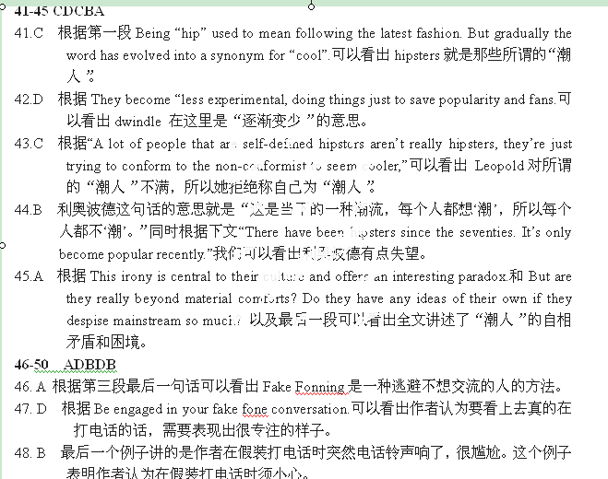
第二部分：阅读理解（第一节20小题，第二节5小题；每小题2分，满分50分）
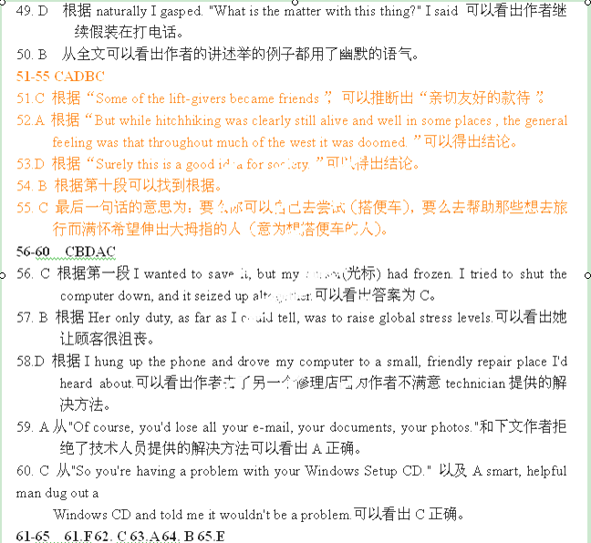
第三部分 写作 (共二小节，满分40分)
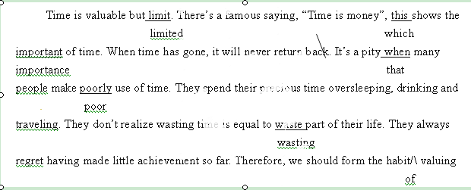第一节：短文改错（满分10分）
